EXPT NO:6 | IMPLEMENTATION OF MULTIVARIATE DISPLAYS
DATE: 24.01.2026 | IMPLEMENTATION OF MULTIVARIATE DISPLAYS

PRE-LAB QUESTIONS
- Why are multivariate displays important in AI analytics?

Multivariate displays help analyze multiple variables together, revealing complex relationships, dependencies, and patterns that improve data understanding and support better AI-driven decisions.

- How do parallel coordinates differ from scatter plots?

Parallel coordinates visualize relationships across multiple variables simultaneously using connected axes, whereas scatter plots are limited to analyzing the relationship between two variables at a time.

- What challenges exist in interpreting multivariate plots?

Challenges include visual clutter, overlapping data points, difficulty in tracking individual records, and misleading interpretations if variables are not properly scaled.

- Where are trellis displays commonly used?

Trellis displays are commonly used in regional analysis, customer segmentation, time-series comparisons, and performance analysis across multiple categories.

- How does multivariate visualization aid model evaluation?

Multivariate visualization aids model evaluation by helping identify feature influence, detect outliers, examine class separability, and visually validate whether model predictions align with underlying data patterns.

OBJECTIVE : To implement advanced multivariate displays for complex data analysis.

SCENARIO A retail analytics firm studies sales, profit, customer segment, and region to optimize business strategy.

IN-LAB TASKS (Using R Language) • Create parallel coordinate plots • Generate bubble charts • Implement trellis displays by region

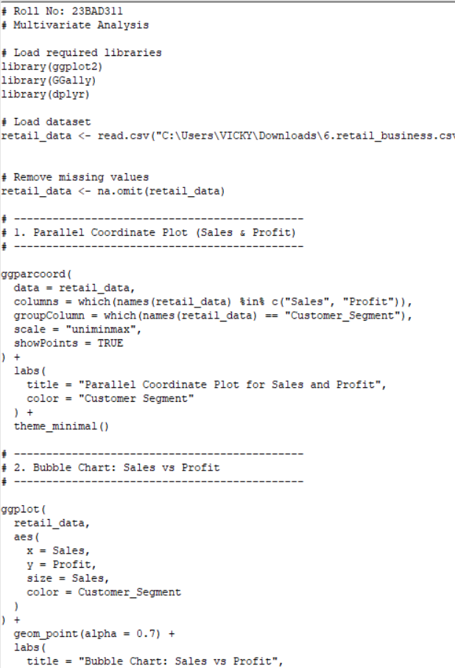
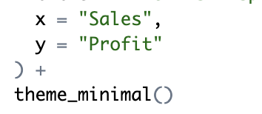

OUTPUT:
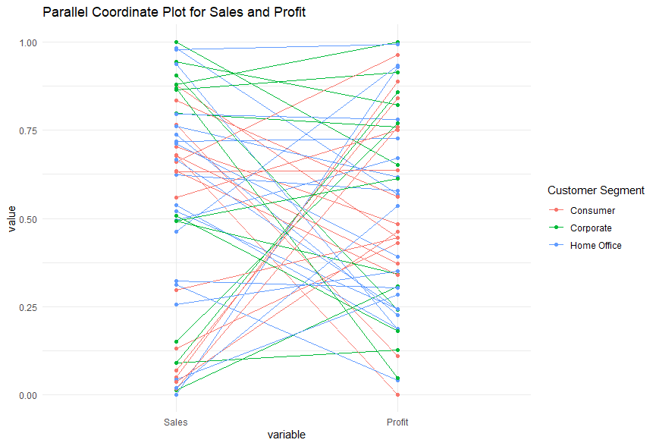

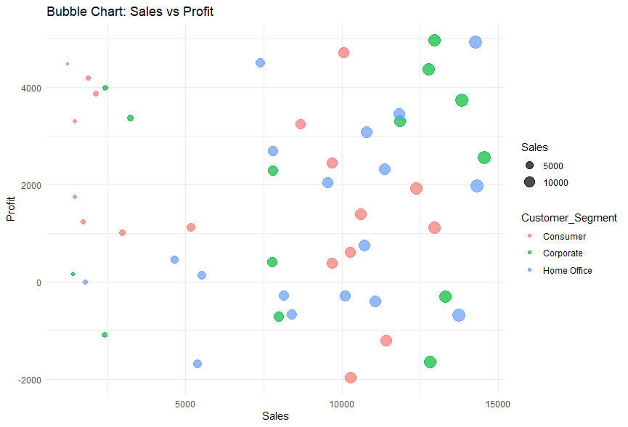
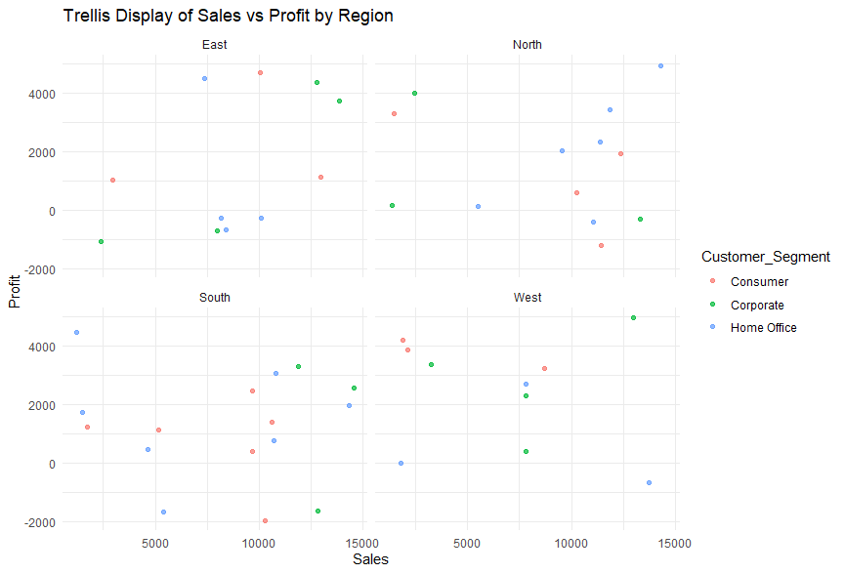
POST-LAB QUESTIONS
- What insights are gained from parallel coordinates?

The parallel coordinate plot shows how Sales and Profit vary together across customer segments, highlighting that some segments achieve high sales but comparatively lower profit, while others maintain balanced performance.

- How does faceting simplify complex data?

Faceting separates the data region-wise, allowing easy comparison of sales–profit patterns across regions without overcrowding a single plot.

- What limitations exist in bubble charts?

Bubble charts may suffer from overlapping bubbles, making it difficult to compare exact values, especially when sales values are close or the dataset is large.

- How can these displays support AI-driven recommendations?

These visualizations help AI systems identify high-performing segments, loss-making patterns, and regional trends, which can be used to recommend pricing, targeting, and regional strategies.

- Suggest improvements for large multivariate datasets.

Improvements include interactive filtering, aggregation, dimensionality reduction, and dynamic tooltips to improve clarity and scalability.

LEARNING OUTCOME: Students apply multivariate visualization for business intelligence.

ASSESSMENT
Description | Max Marks | Marks Awarded
Pre Lab Exercise | 5
In Lab Exercise | 10
Post Lab Exercise | 5
Viva | 10
Total | 30
Faculty Signature

